General information

Similar to the Despite Ni’s biological importance, there is an isotope mass imbalance as well. The sinks are isotopically heavier than the sources. The combination of these imbalances points to a significant missing component (or components) rather than simply incorrect flux and isotopic estimations and measurements. A recent study propose a solution (Little et al., 2020), but further work is clearly necessary. Once the modern marine Ni budget is balanced, we will have identified the key modern controls of marine Ni cycling and this will enable robust modelling of the marine Ni cycle, and the subsequent affects, over time.

**Inputs**

The majority of sources have an isotopically lighter composition than oceans (1.44). Dust, which we assume to share the isotopic composition of the continental crust, has a limited isotopic composition, from -0.1 to +0.2‰ (Cameron et al., 2009; Gall et al., 2012; Gueguen et al., 2013). The dissolved load of rivers is isotopically varied, from +0.29 to +1.38‰, with an abundance weighted isotopic composition of +0.9‰ (Cameron and Vance, 2014; Revels et al., 2021). The riverine particulate load is similar to continental curst and isotopically light compared to the dissolved (Revels et al., 2021). The difference in isotopic composition of rivers and continental crust (*i.e.,* the ultimate source of Ni to rivers), and potentially the dissolved versus particulate load of rivers, can be explained by the formation of Fe-oxyhydroxides, a secondary weathering product of ultra mafic to mafic rocks which host the majority of the crust’s Ni (Spivak-Birndorf et al., 2018). Experiments and natural observations indicate that iron oxides sorb isotopically light Ni (Δ60/58Nidissolved-ferrihydrite = +0.35 ± 0.20‰ 2sd (Wasylenki et al., 2015) and Δ60/58Nidissolved-goethite = +0.77 ± 0.23‰ 2sd (Gueguen et al., 2018)) which agrees well with the offset between rivers and continents. As mentioned, a single study proposed that Mn redox cycling provides a significant input of Ni, and is hypothesized to have an isotopic composition of +3‰ (calculated from a monte carlo simulation of the Ni marine budget and qualitatively from sediments they presumed to have undergone the redox cycling process) (Little et al., 2020). In summary, the majority of sources’ Ni isotopic compositions are restricted to a range of -0.1 to 1.38‰ which are generally lighter than seawater (ca. 1.3 to 1.7‰).

**Oceans**

The deep ocean is globally homogenous, with an isotopic composition around 1.3‰ (Archer et al., 2020; Takano et al., 2017; Yang et al., 2020) while the surface ocean varies. The South Pacific (Takano et al., 2017), North Pacific (Yang et al., 2020), and South Atlantic (Archer et al., 2020) all show significant trends towards isotopically heavy values in the surface waters, up to 1.78‰, which are coupled with surface [Ni] depletions down to ca. 2 nM. On the other hand, the Indian sector of the Southern Ocean, which also displays a less pronounced, but similarly systematic surface [Ni] depletion, shows no isotopic enrichment in the heavier isotopes in surface waters (Wang et al., 2019). This discrepancy may be due to regional biology; Archer et al. (2020), hypothesize that the differing dominating species, cyanobacteria or diatoms, between south (diatom dominated) and north (cyanobacteria dominated) of the polar front results in the differing surface water isotopic compositions (Archer et al., 2020). Additional studies in other diatom dominated waters or through culture experiments could further explore this hypothesis.

**Outputs**

Generally, the major sinks appear to be isotopically heavier than seawater. However, the isotopic compositions of Fe-Mn deposits have an incredibly broad range (-1.8 to +2.5‰), which may be due to diagenetic processes (Gall et al., 2013; Gueguen et al., 2016; Little et al., 2020) (for additional discussion, see section XXX). Experimental results consistently suggest that Fe-Mn deposits should be isotopically light compared to seawater (Δ60/58Niaqueous-Fe oxyhydrides = −0.35 to −0.77‰; Δ60/58NiMn oxides-aqueous −2.76 to −4‰) (Gueguen et al., 2018; Sorensen et al., 2020; Wasylenki et al., 2019, 2015). Generally, studies assign a primary Ni isotopic composition ca. +1.6‰ to Fe-Mn deposits (based on the isotopic composition of Fe-Mn crusts analyzed by Gall et al., 2013 and Gueguen et al., 2016) which is isotopically heavier than deep seawater. Organic rich matter is assumed to have a seawater like isotopic composition (+1.3 ± 0.4) based on the organic rich-pyrite fraction of samples from the upwelling sediments in the Peru Margin (Ciscato et al., 2018); however, there is significant variation within shales (δ60Ni = −0.84 to +2.50‰) which may be due to degrees of sulfidization/removal of Ni into sulfides and variable source Ni (Pašava et al., 2019; Porter et al., 2014). The primary isotopic composition of organic rich sediments is generally assigned a value of 1.2 in mass balance calculations (reflecting the Peru Margin sediments from Ciscato et al., 2018) (Ciscato et al., 2018; Little et al., 2020). Euxinic sulfide-rich sediments from the Black Sea have an isotopic range of +0.3 to +0.6‰ (Vance et al., 2016) and sulfidization in organic matter appears to produce isotopically lighter sediment in shales (Pašava et al., 2019). Generally euxinic sediments are assigned a Ni isotopic composition of +0.45‰ in isotope mass balance calculations (Ciscato et al., 2018; Little et al., 2020).

Insert proposed solutions section

[From this data, there are two paths we can take to resolve the isotope mass imbalance and then apply the isotope mass balance constraint to the marine Ni budget. First, we can explore the variability of the largest Ni sink, Fe-Mn deposits, since without better systematic knowledge of how this sink fractionates Ni isotopes, applying the isotope constraint is near impossible. Second, we can search for new potential fluxes that might contribute to the isotope and mass imbalance. To address each of these paths, I propose to explore the Ni isotope fractionation of Mn oxides and carbonates.]

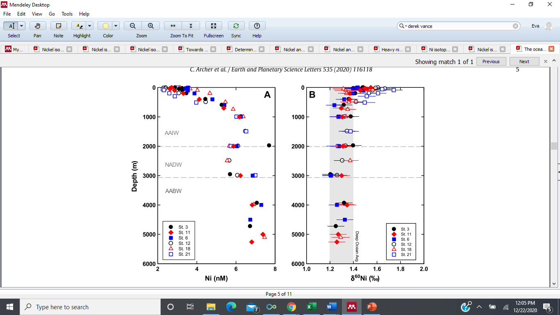Atlantic from Archer et al., 2020

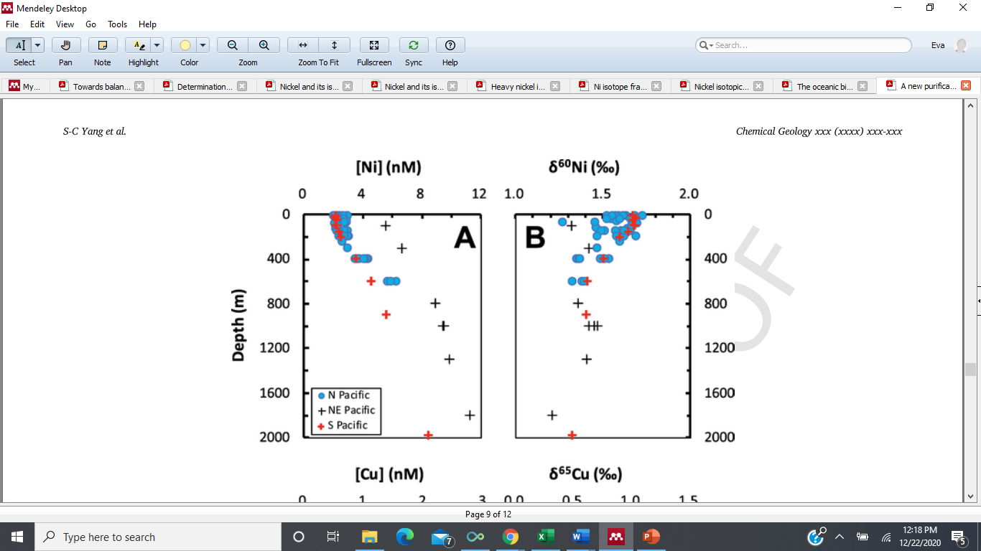Shun-chung Yang et al., 2020

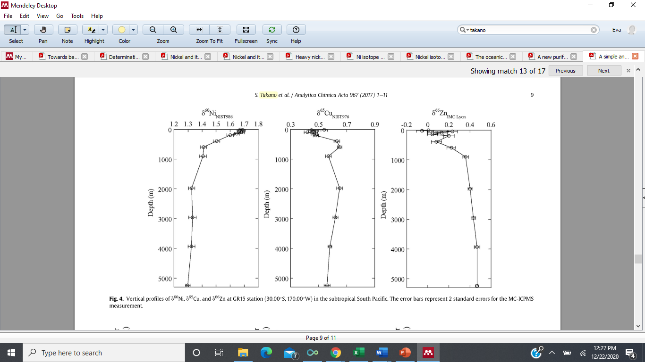Takano et al., 2017 South Pacific

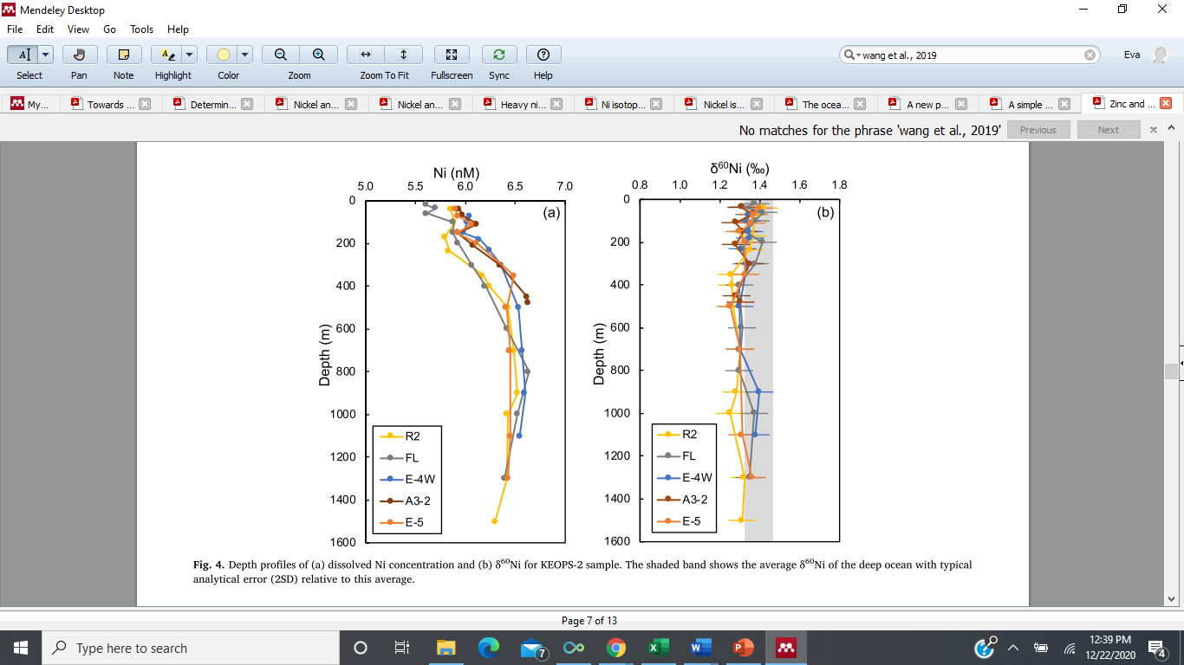Wang et al., 2019 Southern Ocean (Indian Sector)

gall et al., 2013